CONSULATE GENERAL  OF THE REPUBLIC OF POLAND  IN LOS ANGELES |  | KONSULAT GENERALNY  RZECZYPOSPOLITEJ POLSKIEJ  W LOS ANGELES

The Consulate General of the Republic of Poland in Los Angeles

invites you to the

European Jazz @ UCLA

with the performance of the Polish group

Janusz Prusinowski Trio

October 10th to 13th, 2013

Schoenberg Hall, UCLA
Los Angeles, CA

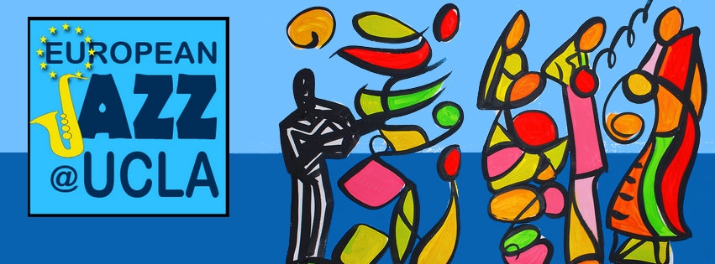

A cooperative celebration by EUrope of culture, arts and original American music

Music is a unique universal language. Every musical piece always tells a story. And each time that story is retold, it changes, the music changes. The change may be simply in the artistic voice or the sound of the musicians, but it also may be a more complex consequence of the particular sensitivity of the artist.

European sensitivity is defined, like any other, by space, time and experience. EUropean Jazz @ UCLA is an attempt to illustrate the European language of jazz, in dialogue with the freedom of expression of this indigenous American art form that has travelled and expanded throughout the world. The story is told in a European voice to the sounds of local European musical experience, reinventing and paying respect to its originators.

In addition to a four-day concert series, the multidimensional festival will feature an exhibition by Croatian artist Roko Ivanda, who visualizes jazz in his work, and master classes by European musicians at UCLA.

Initiated by Croatia and supported by the EU in partnership with UCLA to advance cultural cooperation, EUropean Jazz @ UCLA is a collaboration between nine European consulates located in Los Angeles and San Francisco and UCLA's Herb Alpert School of Music, Center for European and Eurasian Studies, and Thelonious Monk Institute of Jazz Performance.

Complete schedule of the EUropean Jazz @ UCLA

Thursday, October 10th, 2013
7 p.m. Concert (Schoenberg Hall)
- Janusz Prusinowski Trio – Poland
- Emil Viklický Trio – Czech Republic

Friday, October 11th, 2013
7 p.m. Concert (Schoenberg Hall)
- Borna Šercar’s Jazziana Croatica – Croatia
- Swiss Intercontinental Jazz Factory – Switzerland
- North Atlantic Jazz Alliance with special guest Almer Imamovic of Bosnia – Federal Republic of Germany

Saturday, October 12th, 2013
2 p.m. Roundtable Discussion
Borna Šercar’s Jazziana Croatica and other special musical guests will explore the current and future state of jazz in Europe, America and beyond
7 p.m. Concert (Schoenberg Hall)
- Melanie O’Reilly Celtic Jazz Ensemble – Ireland
- JazzIndeed with Michael Schiefel – Federal Republic of Germany

Sunday, October 13th, 2013
2 p.m. Matinee Concert (Schoenberg Hall)
- Orsi and Bálint Sapszon – Hungary
- Georg Breinschmid’s Brein’s Café – Austria
- Dado Moroni–Marco Panascia–Andrea Marcelli – Italy

Event is free and open to the public. RSVP (through the website) recommended.
http://web.international.ucla.edu/sites/eurojazzfestival/#schedule

For event updates, follow @EUJazzFestival on Twitter and Facebook. Further details are available by email via EUropeanjazz@outlook.com

Location and address: All events will take place in UCLA’s Schoenberg Music Building. Schoenberg Hall is located on the first floor of the Schoenberg Music Building at 445 Charles E. Young Drive East, UCLA, Los Angeles, CA 90095.

Directions and parking: For events at UCLA’s Schoenberg Music Building, all-day parking ($12) and short-term parking (payable at pay stations) are available in Parking Structure 2 (enter the campus at Hilgard and Westholme avenues). From Hilgard Ave., enter the east side of campus at Westholme Ave. An immediate left turn leads to Parking Structure 2. From Structure 2, walk north along Charles E. Young Dr. East to Dickson Plaza. Enter the Schoenberg Music Building from Dickson Plaza.

